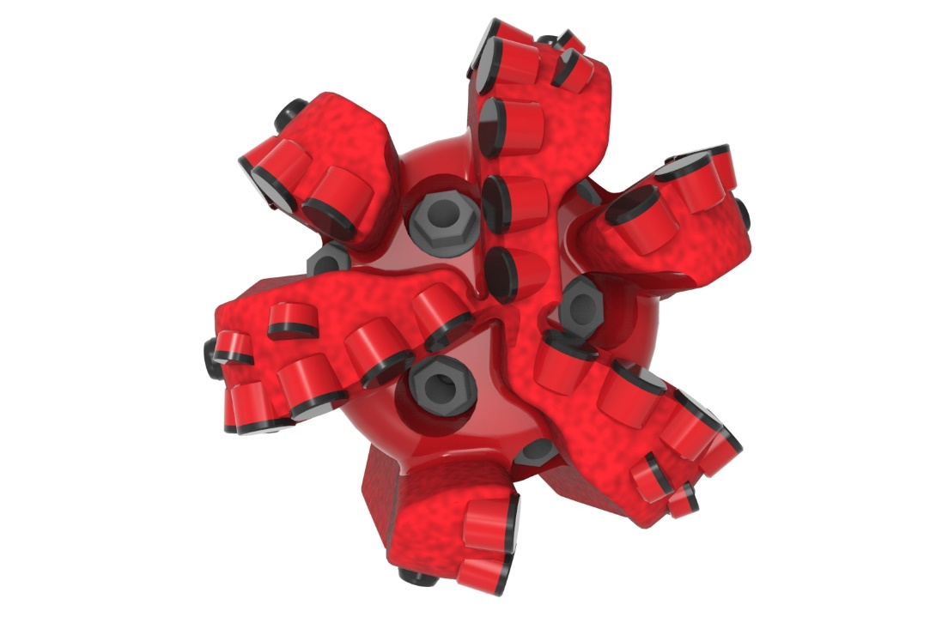
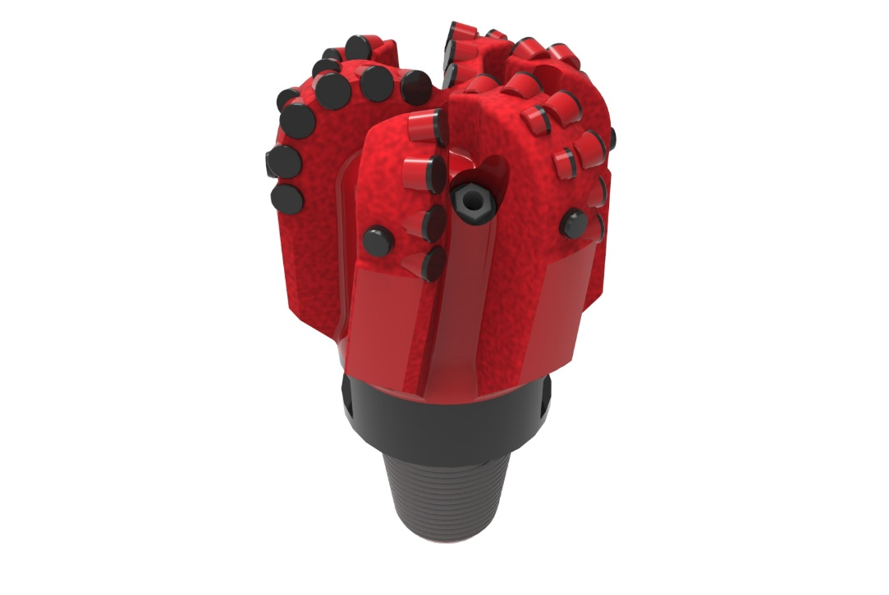

Drill Bit Specifications:
Cutter Size (Primary, Sec) | 5/8”
Cutter Count (Total, Gage) | 30, 6
Blade Count | 6
Gage Length (Inches) | 2.50
Nozzle Count (Primary, Sec.) | 6
Nozzle Series (Primary, Sec.) | 55
JSA (Sq. Inches) | 11.36
Max. TFA (Sq. Inches) | 1.18
Operating Parameters:
Max. Weight on Bit (1,000 Lbs.) | 28
Make-up Torque (ft/lbs) | 8,913
Nominal Dimensions:
Overall Length (Inches) | 11.79
Make Up Length (Inches) | 8.04
Bit Breaker | SKB-21012
Connection | Ø3-1/2" API Reg.
Approx. Weight (Lbs.)  *Long tool joint available upon request (adds 6” to fishing neck, makeup and overall length, and 64 lbs. to approximate weight). | 55

Taylor-Made Features:

- Premium grade cutters maximize ROP and Life
- Nozzle configuration and large open face volume optimize blade cleaning and cuttings removal

616-SR+(K) Nomenclature Explained:

• | 6 | = | Number of Blades
• | 16 | = | Primary Cutter Size (16mm)
• | SR+ | = | Partial Backup Cutters
• | K | = | Bullets


